**Phase one sections:** Homepage, About, Products, News, Contact

**Phase two sections:** Advertise, Careers

**Phase one**

**I) Homepage**

**Logo masthead** – *In production. Insert April 4 FPO logo on white background for time being.*

**Header tabs** – Home, About, Products, News, Contact (add Advertise and Careers in phase 2)

Add search bar in top-right corner of header tab (like FEN Learning)

**Top banner** – *In production. Placeholder: FEN Learning art. Specs:* *1680x1059, RGB.*

**Tagline for Top banner** – Boundless Worlds. Timeless Lessons.

**II)** About **Us**

**Copy for this section –**

Storytellers. Entertainers. Educators. Creators. Put them all together, and you’ve got StoryArc Media.

**{Truncate after this graph} {MORE} button**

We create fun, engaging, interactive experiences that light up kids’ faces and brains. Every day and all around the world, kids enjoy our online games, mobile apps, books, and more, including Poptropica, Funbrain, Galactic Hot Dogs, and Zomberry.

Parents and educators think we’re pretty cool, too, because while StoryArc Media creations are oodles of fun, they also also educate and reward players. And our online games and apps for kids under 13 carry the KidSAFE seal, so adults can be assured that children are exploring in a safe environment.

**Side banner** – *In production. In production. Placeholder: FEN Learning art. Specs: 510x605, RGB.*

Meet **Our Team**

**Copy for this section –**

Our talented team of game developers shares the same passion about our creations that we see among our fans. The enthusiastic feedback we receive from kids and parents every day humbles us, inspires us, and keeps StoryArc Media at our creative best.

**Team headshots, titles and bios –** *being compiled. In the meantime, please display the following three names, titles, and headshots side by side in a row.*

**Jeff Kinney** **Jen MacLean**  **Jeff Faulconer**

Chief Creative Officer President, Kids & Games VP, Product Development

  

*We will have updated team headshots by April 12th. Team photos are being taken April 11th.*

*If possible, we would like the photos to be cropped into circles and displayed about each person’s name, title, and truncated bio – the later expanding when visitors click, “Read More.”*

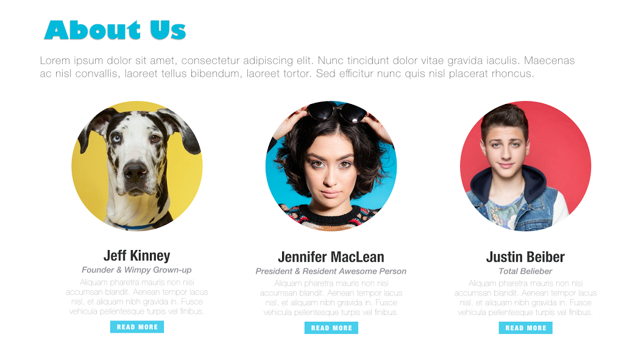

**III)** Our **Creations**

**Copy for this section –** Video games. Graphic novels. And more. Learn about all the cool stuff we create. **{MORE} button**

*For Poptropica, Funbrain and Galactic Hot Dogs, we would prefer to have rectangular banners for each product, followed by a tagline, 2 sentences of body copy, hyperlinked store badges, and, for Poptropica and Funbrain, buttons that link to the online game.*

*Can you provide recommended W & H sizes for each banner? We are open to having the banners each span the width of the site and placing the relevant text and button elements beneath each of them or having the banners fill three rows of a L-side column (approximately half the width of the site) and the relevant text and button elements occupy the R-side column.*

**IV) News, Press, and other good stuff**

**Copy for this section –** Factoids, awards, and press, oh my! Read the latest about StoryArc Media. **{MORE} button**

**Fun facts –** *Will provide unique visual elements and final numbers for all six facts. For the time being, please use small placeholder icons and lay them and the associated text out three in a row over two rows. Alternatively, they could be displayed 2 side by side along 3 rows.*

Total # of registered players: 5.3M

Global presence: 200+ countries

Total # of avatars created: 10.2M

Total # of Realms created: 1.3M

Total # of medallions earned: 9.4M

Total # of problems solved: Too many to count.

**Newsletter** *– Can MailChimp be integrated in the manner outlined in the PDF? If so, will provide a graphical/hero element for this element to be placed between IV) and V). Text is as follows.*

**HEADLINE:** Get the scoop on StoryArc!

**BODY:** Subscribe to our newsletter for the latest on our products, people, and more!

*Email header and body copy to follow.*

VII) **Talk** to Us

*Will provide an office photo by April 12.*

**COPY:** Have an advertising inquiry? Looking for customer service? Hoping to join our team? Here’s how to get in touch. **{MORE} button**

Will update the below contact info with actual details by April 6.

**Advertising**

advertise@storyarc.co

555-555-5555

**Support**

support@storyarc.co

**Careers**

Careers@storyarc.co

**Media**

media@storyarc.co

*Include social media icons that link to StoryArc Facebook, Twitter, and LinkedIn – links to be provided by April 6.*

This page will list contact information for